# **Function array**

1. **Write a program to find out the max number from given array using function.**

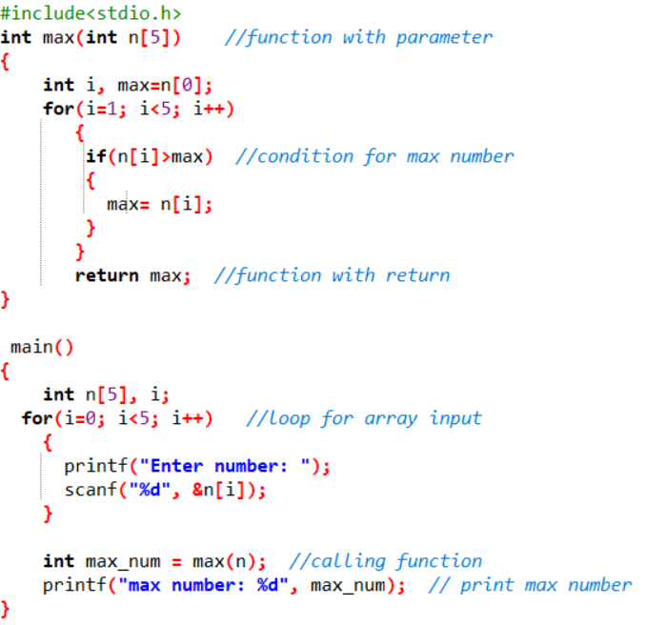

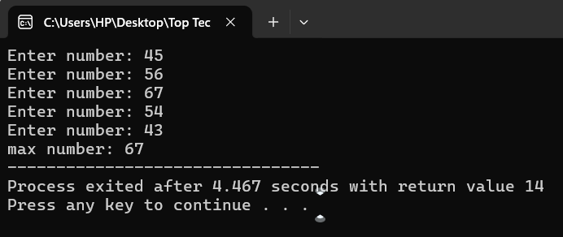**Output:**

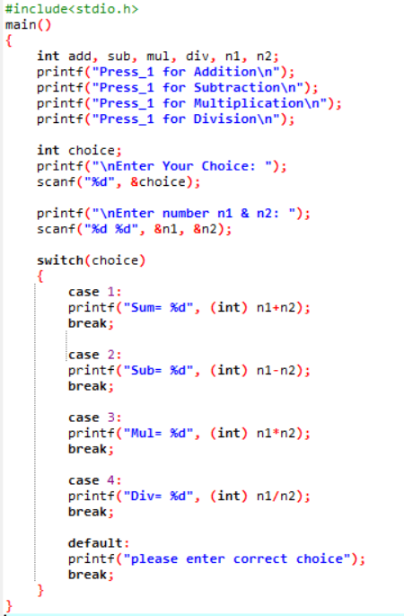**2. WAP of Addition, Subtraction, Multiplication and Division using Switch case.(Must Be Menu Driven)**

**Output:**

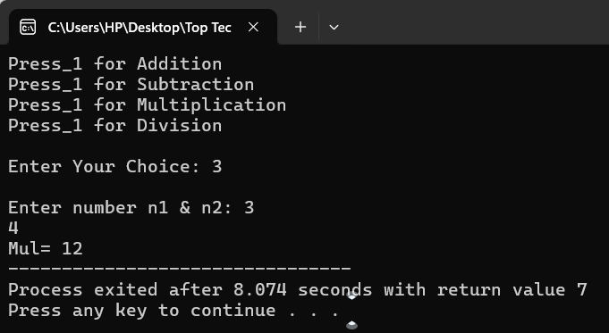

**3. WAP to find reverse of string using recursion**

**4. WAP to find factorial using recursion.**

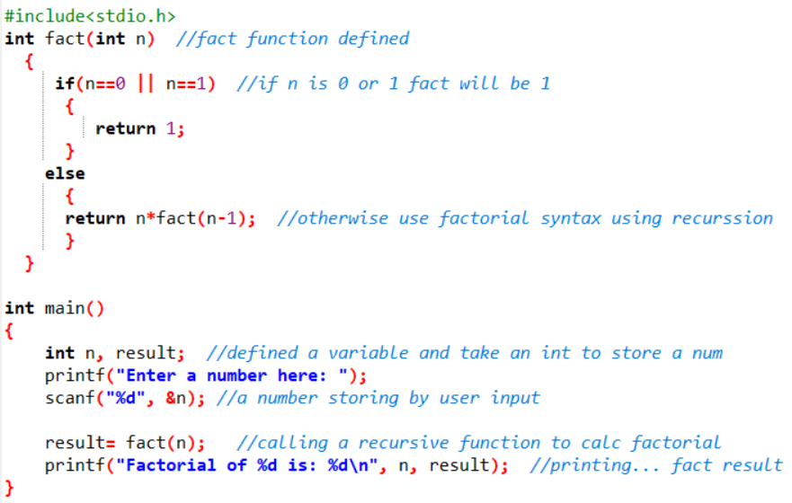

**Output:**

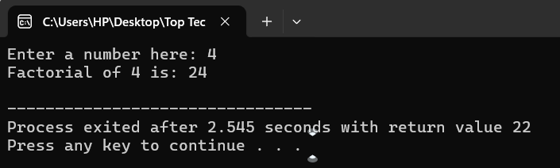

**5. WAP to take two Array input from user and sort them in ascending or descending order as per user’s choice (Topics Covered String).**

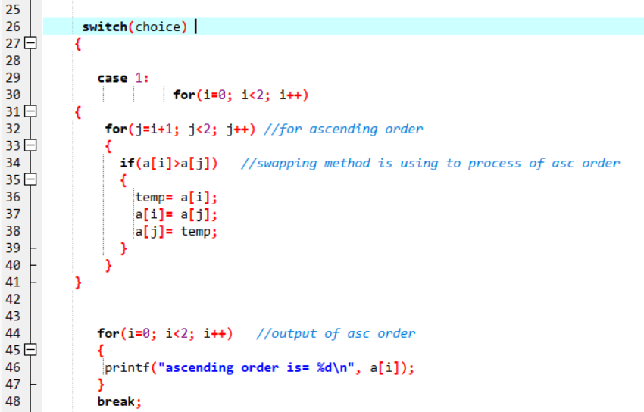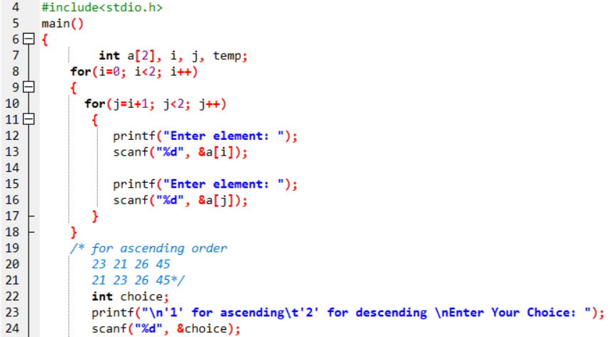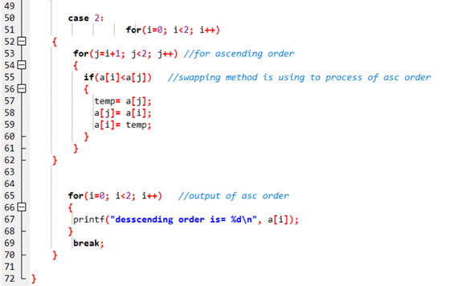

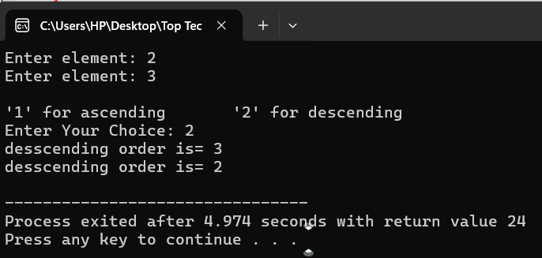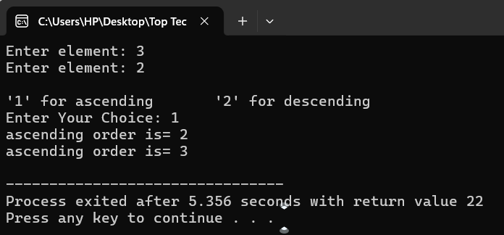**Output: 6. WAP to make addition, Subtraction and multiplication of two 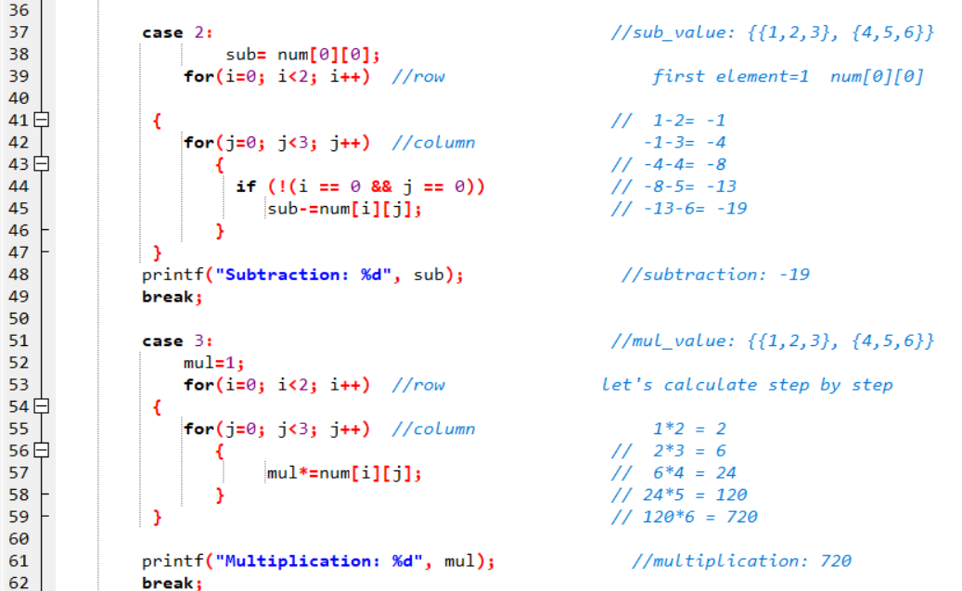matrix using 2-D Array.**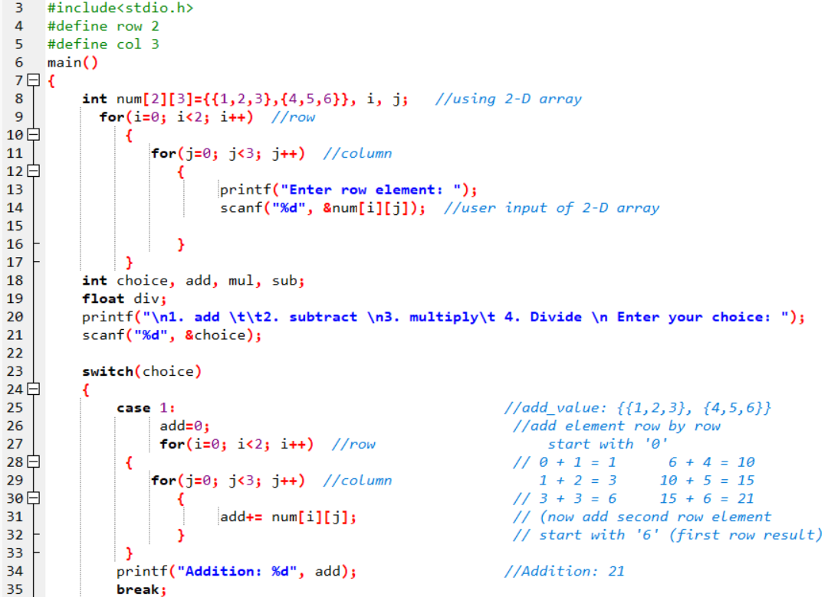

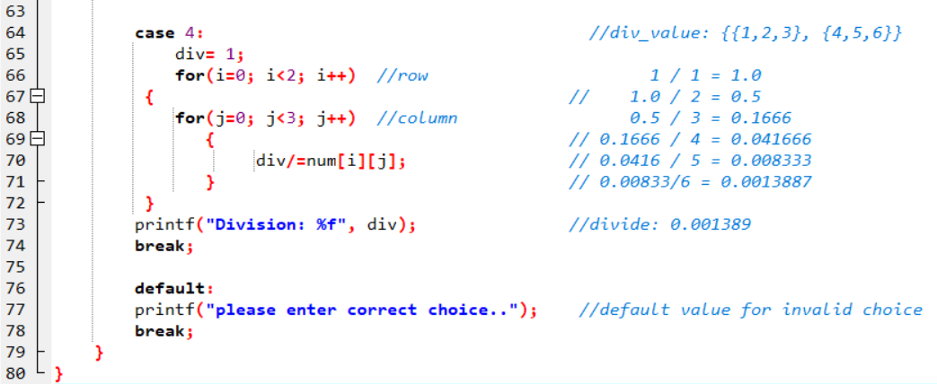

**Output:**

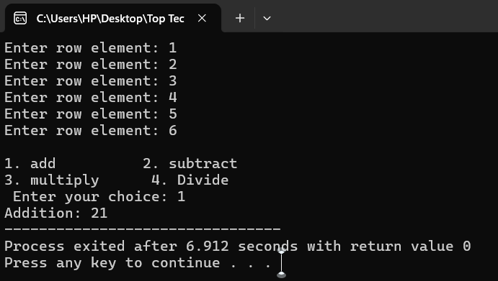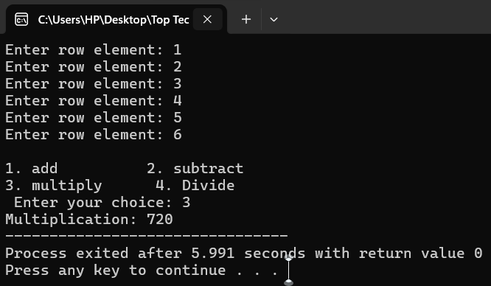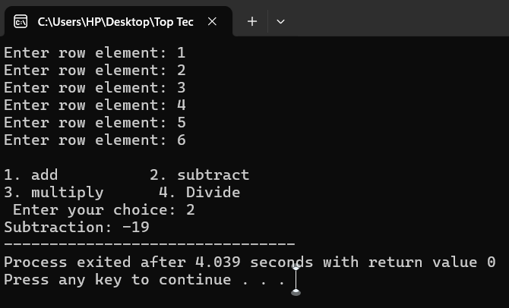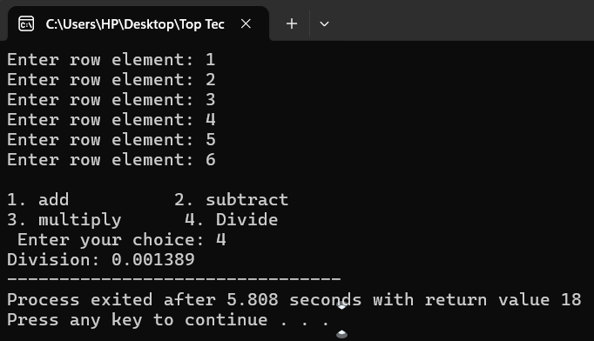

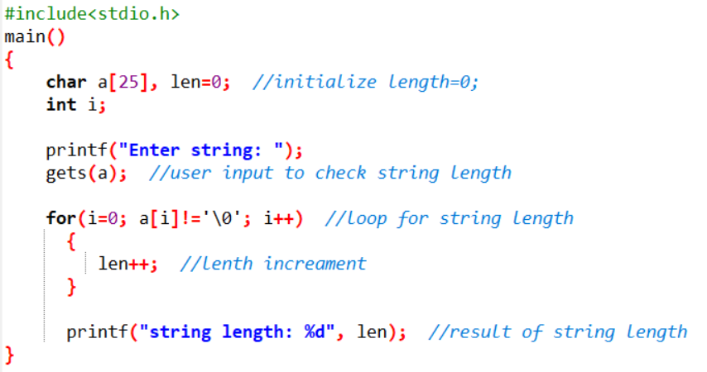**7. WAP Find out length of string without using inbuilt function.**

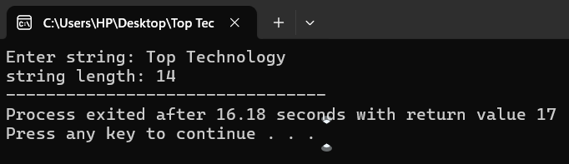**Output:**

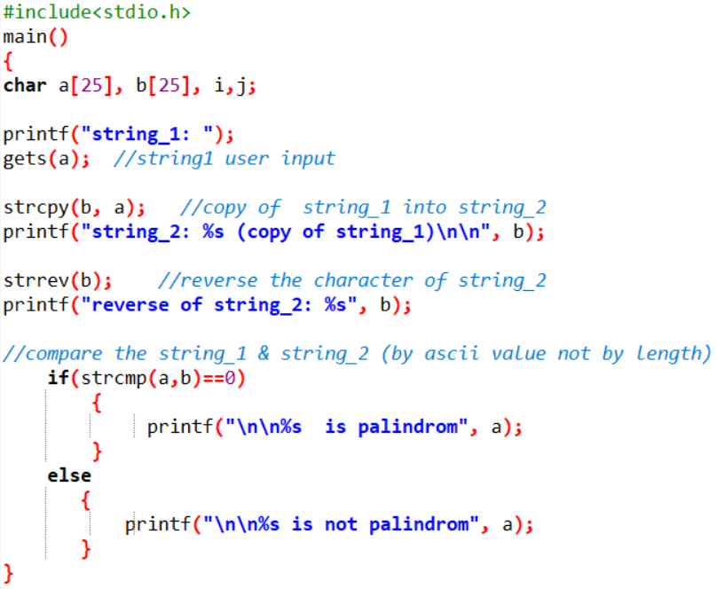**8. WAP to reverse a string and check that the string is palindrome or not.**

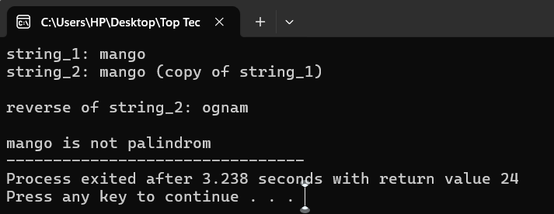**Output:**

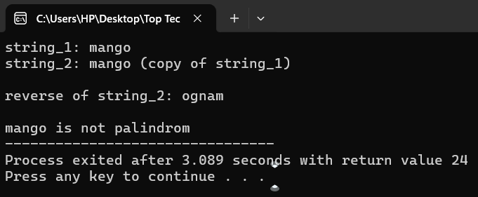

**9.Write a program of structure employee that provides the following**

**a. information -print and display empno, empname, address and age b. Write a program of structure for five employee that provides the following information -print and display empno, empname, address andage**

**9. WAP to show difference between Structure and Union.**

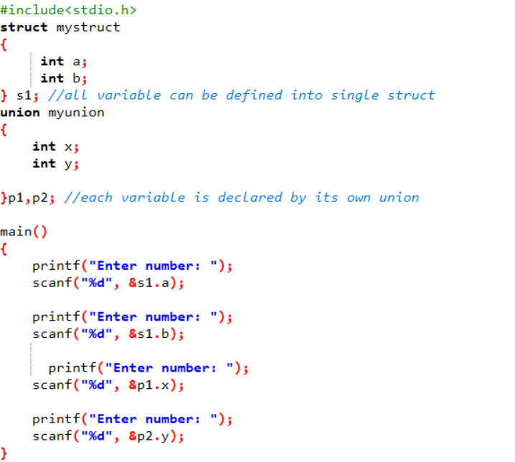

**Output:**

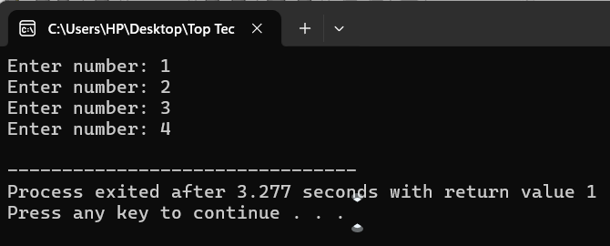

**10.WAP to perform Palindrome number using for loop and function.**

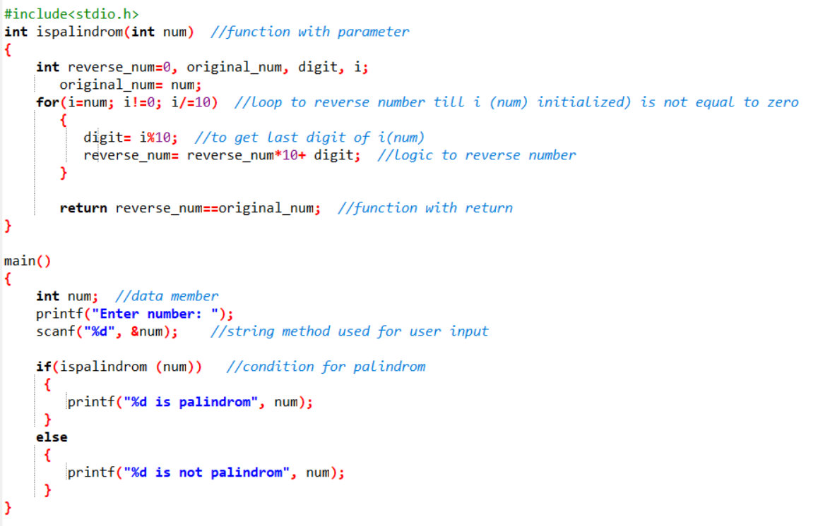

**Output:**

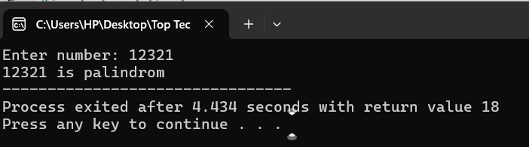

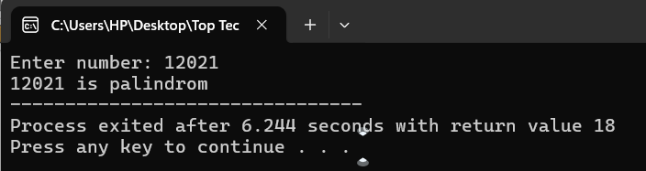

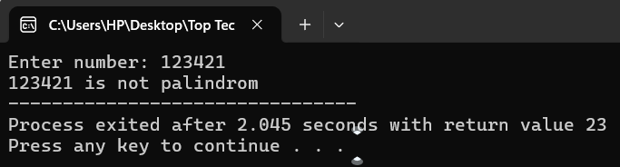

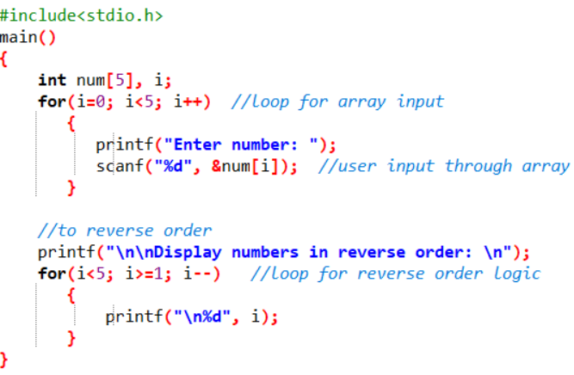**11.WAP to accept 5 numbers from user and display in reverse order using for loop and array.**

**Output:**

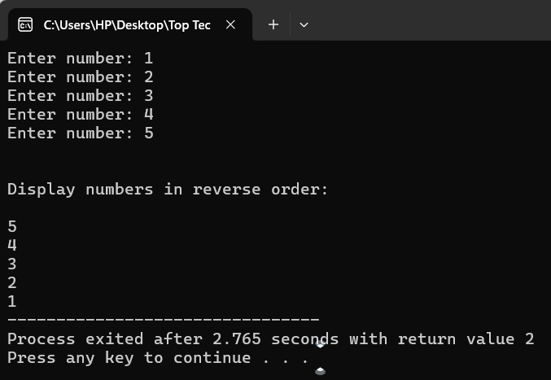

**12.WAP to accept 5 students name and store it in array.**

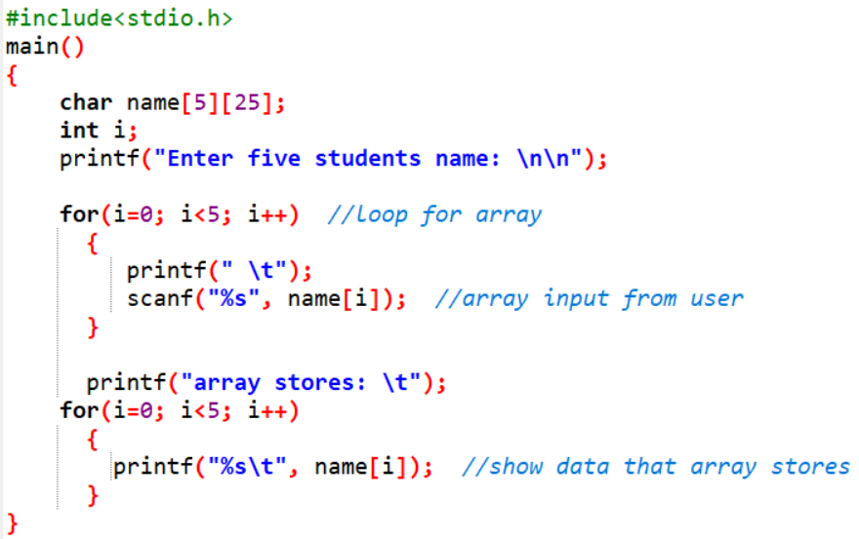

**Output:**

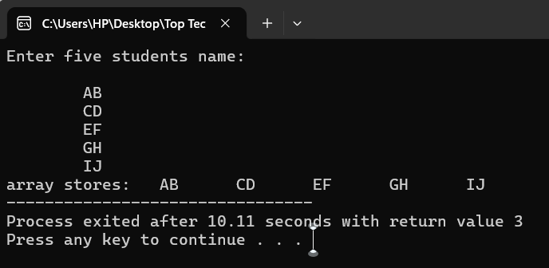

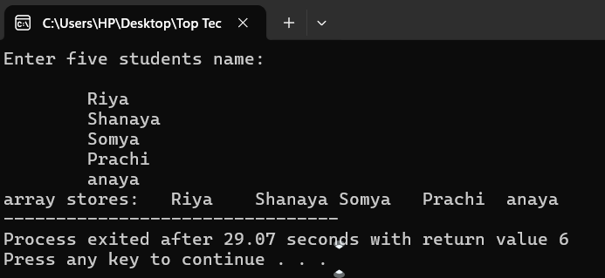

**13.WAP to accept 5 numbers from user and check entered number is even or odd using of array.**

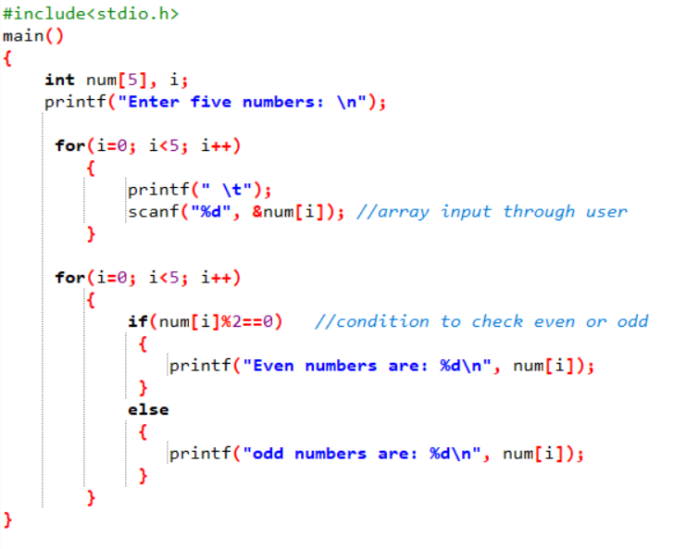

**Output:**

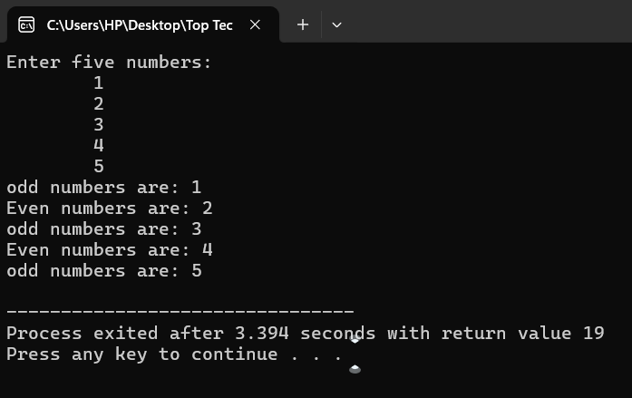

**14.Perform 2D matrix array.**

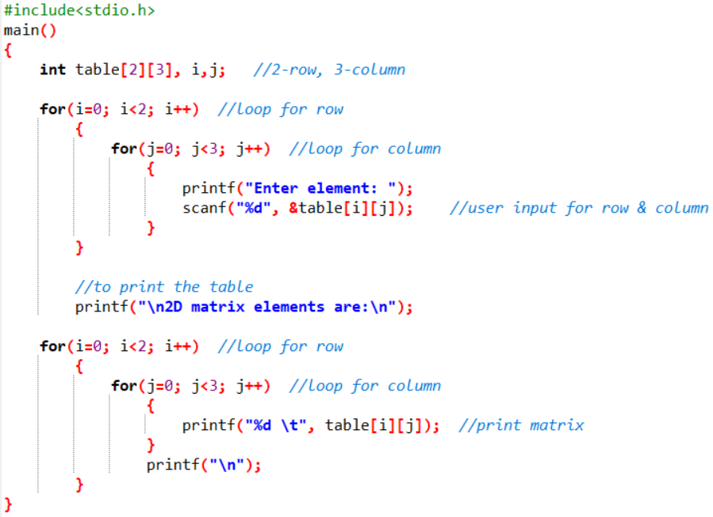

**Output:**

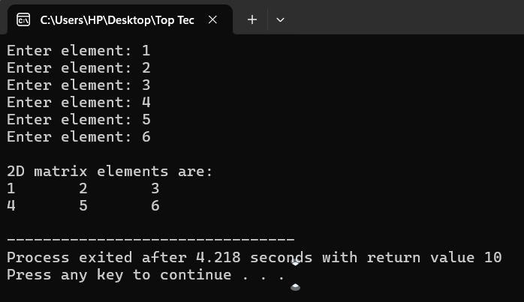

**15.Store 5 numbers in array and sort it in ascending order.**

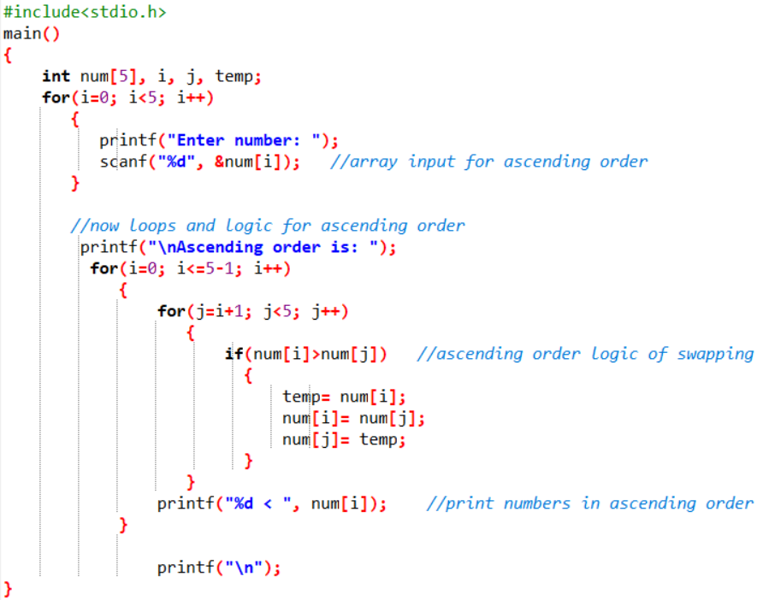

**Output:**

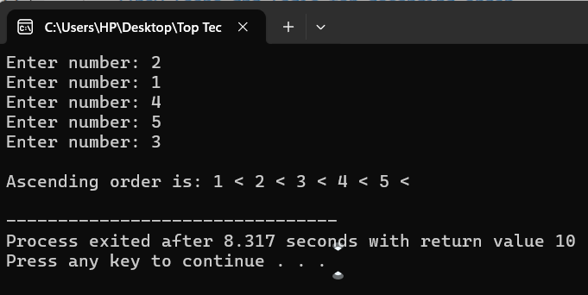

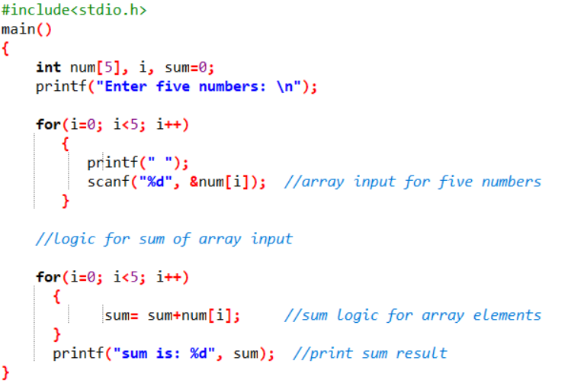**16.Accept 5 numbers from user and perform sum of array.**

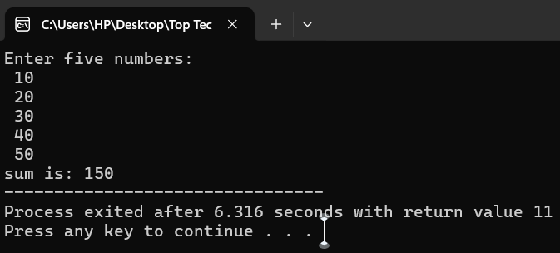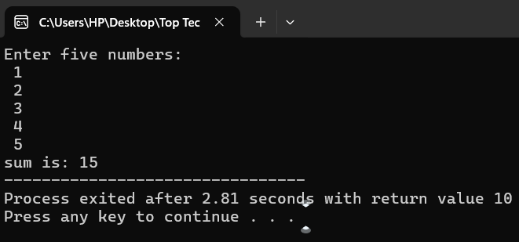**Output:**

**17.WAP to show difference between Structure and Union.**

**Same as Que. 09.**